2002 年 AMC 8 真题与解答
American Mathematics Competitions 8 · 中英双语
共 25 题，限时 40 分钟；单项选择题，每题 1 分，答错不扣分，满分 25 分。
内容来源：LIVE by Po-Shen Loh（live.poshenloh.com）历年 AMC 8 真题与解答，试题经美国数学协会（MAA）官方授权使用；本文档由本地整理生成，供个人学习使用，版权归原作者及 MAA 所有。
编排说明：第一部分为题目（先中文、后英文原题），第二部分为解答与答案，便于先做题后对答案。
第一部分 题目
第 1 题
在一张纸上画一个圆和两条不同的直线。这些图形最多可能有多少个交点？
（A）2 （B）3 （C）4 （D）5 （E）6
English
A circle and two distinct lines are drawn on a sheet of paper. What is the largest possible number of points of intersection of these figures?
(A) 2 (B) 3 (C) 4 (D) 5 (E) 6
第 2 题
可以用多少种不同的 $5 纸币和 $2 纸币组合凑成总额 $17？本题中顺序不重要。
（A）2 （B）3 （C）4 （D）5 （E）6
English
How many different combinations of $5 bills and $2 bills can be used to make a total of $17? Order does not matter in this problem.
(A) 2 (B) 3 (C) 4 (D) 5 (E) 6
第 3 题
四个互不相同的正偶数的平均数最小可能是多少？
（A）3 （B）4 （C）5 （D）6 （E）7
English
What is the smallest possible average of four distinct positive even integers?
(A) 3 (B) 4 (C) 5 (D) 6 (E) 7
第 4 题
年份 2002 是一个回文数（从左往右读和从右往左读相同）。2002 之后下一个回文年份的各位数字乘积是多少？
（A）0 （B）4 （C）9 （D）16 （E）25
English
The year 2002 is a palindrome (a number that reads the same from left to right as it does from right to left). What is the product of the digits of the next year after 2002 that is a palindrome?
(A) 0 (B) 4 (C) 9 (D) 16 (E) 25
第 5 题
Carlos Montado 出生于 2002 年十一月 9 日（星期六）。Carlos 满 706 天时是星期几？
（A）星期一 （B）星期三 （C）星期五 （D）星期六 （E）星期日
English
Carlos Montado was born on Saturday, November 9, 2002. On what day of the week will Carlos be 706 days old?
(A) Monday (B) Wednesday (C) Friday (D) Saturday (E) Sunday
第 6 题
一个鸟浴盆被设计成会溢流，从而可以自我清洁。水以每分钟 20 毫升的速度流入，以每分钟 18 毫升的速度排出。下列某个图显示了鸟浴盆在注水阶段并继续到溢流阶段的水量。是哪一个？
（A）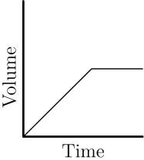
（B）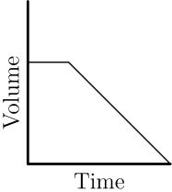
（C）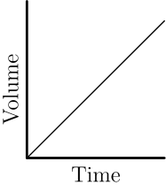
（D）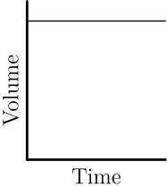
（E）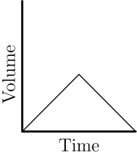
English
A birdbath is designed to overflow so that it will be self-cleaning. Water flows in at the rate of 20 milliliters per minute and drains at the rate of 18 milliliters per minute. One of these graphs shows the volume of water in the birdbath during the filling time and continuing into the overflow time. Which one is it?
(A)
(B)
(C)
(D)
(E)
第 7 题
Sawyer 老师班上的学生被要求对五种糖果进行口味测试。每个学生选择一种糖果。图中显示了他们偏好的条形图。她班上选择糖果 E 的学生占百分之多少？
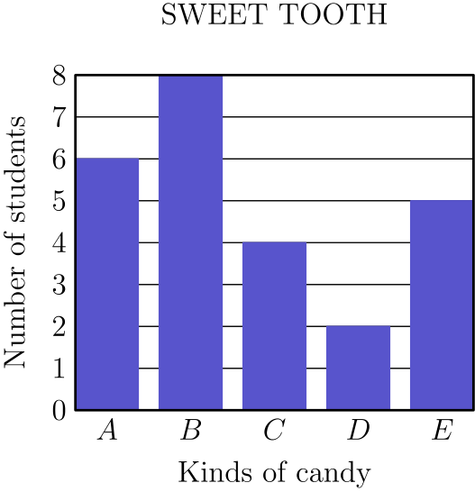
（A）5 （B）12 （C）15 （D）16 （E）20
English
The students in Mrs. Sawyer’s class were asked to do a taste test of five kinds of candy. Each student chose one kind of candy. A bar graph of their preferences is shown. What percent of her class chose candy E?
(A) 5 (B) 12 (C) 15 (D) 16 (E) 20
第 8 题
第 8、9 和 10 题使用随附段落和表格中的数据。
Juan 的旧集邮天地
Juan 按国家和邮票发行年代整理他的收藏。他在邮票店购买这些邮票的价格为：巴西和法国每张 6¢，秘鲁每张 4¢，西班牙每张 5¢。（巴西和秘鲁是南美国家，法国和西班牙在欧洲。）
各年代邮票数量
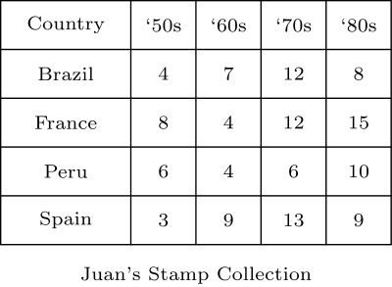
他的欧洲邮票中，有多少张是在 80 年代发行的？
（A）9 （B）15 （C）18 （D）24 （E）42
English
Problems 8, 9, and 10 use the data found in the accompanying paragraph and table.
Juan’s Old Stamping Grounds
Juan organizes the stamps in his collection by country and by the decade in which they were issued. The prices he paid for them at a stamp shop were: Brazil and France, 6¢ each, Peru 4¢ each, and Spain 5¢ each. (Brazil and Peru are South American countries and France and Spain are in Europe.)
Number of Stamps by Decade
How many of his European stamps were issued in the ‘80s?
(A) 9 (B) 15 (C) 18 (D) 24 (E) 42
第 9 题
他在 70 年代以前发行的南美邮票花费了
（A）$0.40 （B）$1.06 （C）$1.80 （D）$2.38 （E）$2.64
English
His South American stamps issued before the ‘70s cost him
(A) $0.40 (B) $1.06 (C) $1.80 (D) $2.38 (E) $2.64
第 10 题
他 70 年代邮票的平均价格最接近
（A）3.5¢ （B）4¢ （C）4.5¢ （D）5¢ （E）5.5¢
English
The average price of his ‘70s stamps is closest to
(A) 3.5¢ (B) 4¢ (C) 4.5¢ (D) 5¢ (E) 5.5¢
第 11 题
一列正方形由相同的正方形瓷砖组成。每个正方形的边长比前一个正方形多一块瓷砖长度。图中显示了前三个正方形。第七个正方形比第六个正方形多需要多少块瓷砖？
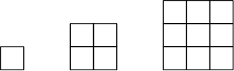
（A）11 （B）12 （C）13 （D）14 （E）15
English
A sequence of squares is made of identical square tiles. The edge of each square is one tile length longer than the edge of the previous square. The first three squares are shown. How many more tiles does the seventh square require than the sixth?
(A) 11 (B) 12 (C) 13 (D) 14 (E) 15
第 12 题
一个桌游转盘分成标有 A、B、C 的三个区域。指针停在区域 A 的概率是 1/3，停在区域 B 的概率是 1/2。指针停在区域 C 的概率是
（A）1/12 （B）1/6 （C）1/5 （D）1/3 （E）2/5
English
A board game spinner is divided into three regions labeled A, B and C. The probability of the arrow stopping on region A is 1/3 and on region B is 1/2. The probability of the arrow stopping on region C is
(A) 1/12 (B) 1/6 (C) 1/5 (D) 1/3 (E) 2/5
第 13 题
Bert 生日时得到一个盒子，装满时能容纳 125 颗糖豆。几周后，Carrie 得到一个装满糖豆的更大盒子。她的盒子在高、宽、长三个方向上都是 Bert 盒子的两倍。Carrie 大约得到了多少颗糖豆？
（A）250 （B）500 （C）625 （D）750 （E）1000
English
For his birthday, Bert gets a box that holds 125 jellybeans when filled to capacity. A few weeks later, Carrie gets a larger box full of jellybeans. Her box is twice as high, twice as wide and twice as long as Bert’s. Approximately, how many jellybeans did Carrie get?
(A) 250 (B) 500 (C) 625 (D) 750 (E) 1000
第 14 题
一位商人把一大批商品降价 30%。后来，商人又在促销价基础上降价 20%，并声称这些商品的最终价格比原价低 50%。总折扣实际是
（A）35% （B）44% （C）50% （D）56% （E）60%
English
A merchant offers a large group of items at 30% off. Later, the merchant takes 20% off these sale prices and claims that the final price of these items is 50% off the original price. The total discount is
(A) 35% (B) 44% (C) 50% (D) 56% (E) 60%
第 15 题
下列哪个多边形面积最大？
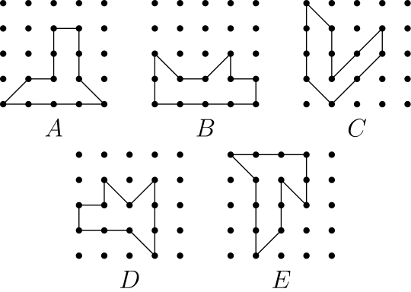
（A）A （B）B （C）C （D）D （E）E
English
Which of the following polygons has the largest area?
(A) A (B) B (C) C (D) D (E) E
第 16 题
如图，在一个 3-4-5 直角三角形的各边上分别构造等腰直角三角形。大写字母表示每个三角形的面积。下列哪一项正确？
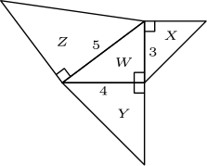
（A）X + Z = W + Y （B）W + X = Z （C）3X + 4Y = 5Z （D）X + W = 1/2(Y + Z) （E）X + Y = Z
English
Right isosceles triangles are constructed on the sides of a 3-4-5 right triangle, as shown. A capital letter represents the area of each triangle. Which one of the following is true?
(A) X + Z = W + Y (B) W + X = Z (C) 3X + 4Y = 5Z (D) X + W = 1/2(Y + Z) (E) X + Y = Z
第 17 题
在一场有十道题的数学竞赛中，学生答对一题得 5 分，答错一题扣 2 分。Olivia 回答了所有题，得分为 29。她答对了多少题？
（A）5 （B）6 （C）7 （D）8 （E）9
English
In a mathematics contest with ten problems, a student gains 5 points for a correct answer and loses 2 points for an incorrect answer. If Olivia answered every problem and her score was 29, how many correct answers did she have?
(A) 5 (B) 6 (C) 7 (D) 8 (E) 9
第 18 题
Gage 连续 5 天每天滑冰 1 小时 15 分钟，又连续 3 天每天滑冰 1 小时 30 分钟。为了让整个九天期间平均每天滑冰 85 分钟，他第九天需要滑冰多久？
（A）1 小时 （B）1 小时 10 分钟 （C）1 小时 20 分钟 （D）1 小时 40 分钟 （E）2 小时
English
Gage skated 1 hr 15 min each day for 5 days and 1 hr 30 min each day for 3 days. How long would he have to skate the ninth day in order to average 85 minutes of skating each day for the entire time?
(A) 1 hr (B) 1 hr 10 min (C) 1 hr 20 min (D) 1 hr 40 min (E) 2 hr
第 19 题
99 和 999 之间有多少个整数恰好含有一个数字 0？
（A）72 （B）90 （C）144 （D）162 （E）180
English
How many whole numbers between 99 and 999 contain exactly one 0?
(A) 72 (B) 90 (C) 144 (D) 162 (E) 180
第 20 题
三角形 XYZ 的面积是 8 平方英寸。点 A 和 B 分别是全等线段 XY 和 XZ 的中点。高 XC 平分 YZ。阴影区域的面积（平方英寸）是
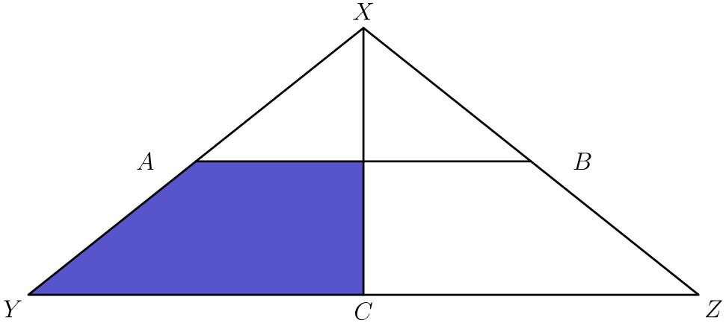
（A）1 1/2 （B）2 （C）2 1/2 （D）3 （E）3 1/2
English
The area of triangle XYZ is 8 square inches. Points A and B are midpoints of congruent segments XY and XZ. Altitude XC bisects YZ. The area (in square inches) of the shaded region is
(A) 1 1/2 (B) 2 (C) 2 1/2 (D) 3 (E) 3 1/2
第 21 题
Harold 将一枚五美分硬币抛四次。他得到的正面数至少和反面数一样多的概率是
（A）5/16 （B）3/8 （C）1/2 （D）5/8 （E）11/16
English
Harold tosses a nickel four times. The probability that he gets at least as many heads as tails is
(A) 5/16 (B) 3/8 (C) 1/2 (D) 5/8 (E) 11/16
第 22 题
六个棱长为一英寸的立方体如图固定在一起。求总表面积，单位为平方英寸。包括顶面、底面和侧面。
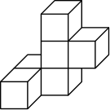
（A）18 （B）24 （C）26 （D）30 （E）36
English
Six cubes, each an inch on an edge, are fastened together, as shown. Find the total surface area in square inches. Include the top, bottom, and sides.
(A) 18 (B) 24 (C) 26 (D) 30 (E) 36
第 23 题
图中显示了瓷砖地板的一个角。如果整个地板都按这种方式铺设，并且四个角都像这个角一样，那么较深色瓷砖占整个瓷砖地板的几分之几？
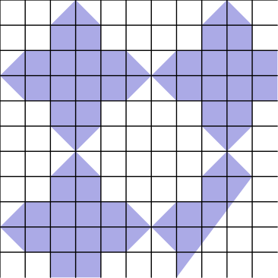
（A）1/3 （B）4/9 （C）1/2 （D）5/9 （E）5/8
English
A corner of a tiled floor is shown. If the entire floor is tiled in this way and each of the four corners looks like this one, then what fraction of the tiled floor is made of darker tiles?
(A) 1/3 (B) 4/9 (C) 1/2 (D) 5/9 (E) 5/8
第 24 题
Miki 有一打大小相同的橙子和一打大小相同的梨。Miki 用榨汁机从 3 个梨中榨出 8 盎司梨汁，从 2 个橙子中榨出 8 盎司橙汁。她用相同数量的梨和橙子制作梨橙混合果汁。混合果汁中梨汁占百分之多少？
（A）30 （B）40 （C）50 （D）60 （E）70
English
Miki has a dozen oranges of the same size and a dozen pears of the same size. Miki uses her juicer to extract 8 ounces of pear juice from 3 pears and 8 ounces of orange juice from 2 oranges. She makes a pear-orange juice blend from an equal number of pears and oranges. What percent of the blend is pear juice?
(A) 30 (B) 40 (C) 50 (D) 60 (E) 70
第 25 题
Loki、Moe、Nick 和 Ott 是好朋友。Ott 没有钱，但其他人有钱。Moe 给了 Ott 自己钱数的五分之一，Loki 给了 Ott 自己钱数的四分之一，Nick 给了 Ott 自己钱数的三分之一。每个人给 Ott 的钱数相同。现在 Ott 拥有这群人总钱数的几分之几？
（A）1/10 （B）1/4 （C）1/3 （D）2/5 （E）1/2
English
Loki, Moe, Nick and Ott are good friends. Ott had no money, but the others did. Moe gave Ott one-fifth of his money, Loki gave Ott one-fourth of his money and Nick gave Ott one-third of his money. Each gave Ott the same amount of money. What fractional part of the group’s money does Ott now have?
(A) 1/10 (B) 1/4 (C) 1/3 (D) 2/5 (E) 1/2

第二部分 解答
答案速查：
题号 1 2 3 4 5 6 7 8 9
答案 D A C B C A E D B
题号 10 11 12 13 14 15 16 17 18
答案 E C B E B E E C E
题号 19 20 21 22 23 24 25
答案 D D E C B B B
答案串：DACBCAEDBECBEBEECEDDECBBB
第 1 题 答案 D
一条直线和一个圆最多相交于两个点，两条不同直线最多相交于一个点。
安排两条直线都与圆相交两次，并且两条直线在另一个点相交。这样交点的总数为
2+2+1=5。
所以正确答案是D。
English
A line and a circle can intersect at no more than two points, and two distinct lines can intersect at no more than one point.
Arrange the two lines so each meets the circle twice and the two lines meet at a different point. This gives
2+2+1=5.
Thus,Dis the correct answer.
第 2 题 答案 A
因为总额 $17 是奇数，$5 纸币的张数必须是奇数。
一张 $5 纸币还剩 $12，也就是六张 $2 纸币。三张 $5 纸币还剩 $2，也就是一张 $2 纸币。五张 $5 纸币太多。
因此共有 2 种组合。
所以正确答案是A。
English
Since the total $17 is odd, the number of $5 bills must be odd.
One $5 bill leaves $12, which is six $2 bills. Three $5 bills leave $2, which is one $2 bill. Five $5 bills is too much.
Therefore, there are 2 combinations.
Thus,Ais the correct answer.
第 3 题 答案 C
要得到最小可能平均数，应选 4 个最小的正偶数。
这给出
(2 + 4 + 6 + 8)/4 = 20/4
= 5。
所以正确答案是C。
English
To get the smallest possible average, we want to use the smallest 4 positive even integers.
This can be achieved as follows:
(2 + 4 + 6 + 8)/4 = 20/4
= 5.
Thus,Cis the correct answer.
第 4 题 答案 B
我们不想增加千位，所以千位仍可保持为 2。
因此必须把百位和十位增加到 1，得到下一个回文数 2112。它的各位数字乘积为 4。
所以正确答案是B。
English
We don’t want to increase the thousands digit, so we can keep that as 2.
This means that we have to increase the tens and hundreds digits to 1, to yield the next palindrome of 2112. The product of its digits is 4.
Thus,Bis the correct answer.
第 5 题 答案 C
星期每 7 天循环一次。经过 700 天后，星期仍然是星期六。
再过 6 天后，就是星期五。
所以正确答案是C。
English
The days of the week cycle every 7 days. After 700 days, the day of the week will still be Saturday.
After 6 more days, the day of the week will be Friday.
Thus,Cis the correct answer.
第 6 题 答案 A
鸟浴盆溢流前，每分钟净增加 20-18=2 毫升水，所以水量稳定上升。
鸟浴盆装满后，流入的多余水会溢出，所以水量保持不变。只有图 A 显示先上升再水平的图线。
所以正确答案是A。
English
Before the birdbath overflows, it gains 20-18=2 milliliters of water per minute, so its volume increases steadily.
Once the birdbath is full, the incoming extra water overflows, so the volume remains constant. Only graph A shows an increasing line followed by a horizontal line.
Thus,Ais the correct answer.
第 7 题 答案 E
班上共有
6 + 8 + 4 + 2 + 5 = 25
名学生。选择 E 的百分比为
100 · 5/25 = 100/5 = 20 %。
所以正确答案是E。
English
There are a total of
6 + 8 + 4 + 2 + 5 = 25
students in the class. The percent that chose E is
100 · 5/25 = 100/5 = 20 %.
Thus,Eis the correct answer.
第 8 题 答案 D
法国和西班牙是欧洲国家。这两个国家在 80 年代的邮票数分别是 15 和 9，总计
15 + 9 = 24
张。
所以正确答案是D。
English
Note that France and Spain are the European countries. The number of ‘80s stamps from these countries respectively is 15 and 9 for a total of
15 + 9 = 24
stamps.
Thus,Dis the correct answer.
第 9 题 答案 B
巴西和秘鲁是南美国家。
巴西在 70 年代以前有 4+7=11 张邮票，费用为 11·6=66 美分。秘鲁有 6+4=10 张这样的邮票，费用为 10·4=40 美分。
总费用为 66+40=106 美分，也就是 $1.06。
所以正确答案是B。
English
Brazil and Peru are the South American countries.
Brazil has 4+7=11 stamps before the ‘70s, costing 11·6=66 cents. Peru has 6+4=10 such stamps, costing 10·4=40 cents.
The total cost is 66+40=106 cents, or $1.06.
Thus,Bis the correct answer.
第 10 题 答案 E
70 年代邮票的费用为
12·6+12·6
+6·4+13·5
=72+72+24+65
=233
美分。
邮票共有 12+12+6+13=43 张，所以平均费用为 233÷43，略大于 5 美分，最接近 5.5 美分。
所以正确答案是E。
English
The ‘70s stamps cost
12·6+12·6
+6·4+13·5
=72+72+24+65
=233
cents.
There are 12+12+6+13=43 stamps, so the average cost is 233÷43, a little more than 5 cents and closest to 5.5 cents.
Thus,Eis the correct answer.
第 11 题 答案 C
第六个和第七个正方形的边长分别相当于 6 块和 7 块瓷砖的边长。
它们分别使用 6²=36 和 7²=49 块瓷砖，所以第七个正方形多需要 49-36=13 块瓷砖。
所以正确答案是C。
English
The sixth and seventh squares have side lengths 6 and 7 tile lengths.
They use 6²=36 and 7²=49 tiles, respectively, so the seventh square requires 49-36=13 more tiles.
Thus,Cis the correct answer.
第 12 题 答案 B
总概率为 1。要得到 C 的概率，需要减去落在 A 和 B 的概率：
1 - 1/3 - 1/2 = 1/6。
所以正确答案是B。
English
The total probability is 1. We need to subtract the probability of the spinner landing on B and A to get C, which is
1 - 1/3 - 1/2 = 1/6.
Thus,Bis the correct answer.
第 13 题 答案 E
更大的盒子大约能装
125 · 2 · 2 · 2 = 1000
颗糖豆。
所以正确答案是E。
English
The larger box will have approximately
125 · 2 · 2 · 2 = 1000
jellybeans.
Thus,Eis the correct answer.
第 14 题 答案 B
设原价为 x。降价 30% 后，价格是 0.70x。
再从该促销价上减去 20%，剩下 0.80·0.70x=0.56x。
顾客支付原价的 56%，所以总折扣是 44%。
所以正确答案是B。
English
Let the original price be x. After the 30% discount, the price is 0.70x.
Taking another 20% off that sale price leaves 0.80·0.70x=0.56x.
The customer pays 56% of the original price, so the total discount is 44%.
Thus,Bis the correct answer.
第 15 题 答案 E
每个多边形包含的方格数可通过把多边形分成单位正方形和边长为 1 的直角三角形，再相加得到。
单位正方形面积算作 1，三角形面积算作 0.5。
A 的总面积为 5，B 为 5，C 为 5，D 为 4.5，E 为 5.5。
所以正确答案是E。
English
The number of boxes enclosed by each polygon can be obtained by dividing the polygon into unit squares and right triangles with sidelength 1 and adding up their values.
The unit squares count as 1 and the triangles count as 0.5.
A has a total area of 5, B has 5, C has 5, D has 4.5, and E has 5.5.
Thus,Eis the correct answer.
第 16 题 答案 E
对于建在边长为 s 的边上的等腰直角三角形，两条直角边长为 s，所以面积为 s²/2。
W=(3·4)/2=6,
X=3²/2=4.5,
Y=4²/2=8,
Z=5²/2=12.5
。
这些值满足 X+Y=Z，而其他列出的等式不成立。
所以正确答案是E。
English
For a right isosceles triangle built on a side of length s, the two legs have length s, so its area is s²/2.
W=(3·4)/2=6,
X=3²/2=4.5,
Y=4²/2=8,
Z=5²/2=12.5.
These values satisfy X+Y=Z, and the other listed equations do not.
Thus,Eis the correct answer.
第 17 题 答案 C
设 x 为答对题数。那么她答错了 10 - x 题。
她的总分为
5x - 2(10 - x) = 7x - 20。
该值等于 29，解得
7x - 20 = 29
x = 7。
所以正确答案是C。
English
Let x be the number of correct answers. Then she answered 10 - x questions incorrectly.
This gives her a total score of
5x - 2(10 - x) = 7x - 20.
We know that this equals 29, and solving yields
7x - 20 = 29
x = 7.
Thus,Cis the correct answer.
第 18 题 答案 E
Gage 已经滑冰的总时间为
5 · 75 + 3 · 90 = 645
分钟。
若平均每天滑冰 85 分钟，那么 9 天总共需要滑冰
85 · 9 = 765
分钟。
因此 Gage 最后一天需要滑冰
765 - 645 = 120
分钟。120 分钟等于 2 小时。
所以正确答案是E。
English
Gage has skated a total of
5 · 75 + 3 · 90 = 645
minutes.
For an average of 85 minutes over 9 days, Gage must have skated a total of
85 · 9 = 765
minutes.
This means that Gage must skate
765 - 645 = 120
minutes on the last day. Note that 120 minutes is the same as 2 hours.
Thus,Eis the correct answer.
第 19 题 答案 D
数字 0 可以在十位或个位，这有 2 种选择。
其他每一位各有 9 种选择，所以共有
2 · 9 · 9 = 162
个数。
所以正确答案是D。
English
Note that the 0 digit can either be the tens or the units digit. This gives us 2 options for this.
There are 9 options for each of the other digits for a total of
2 · 9 · 9 = 162
numbers.
Thus,Dis the correct answer.
第 20 题 答案 D
因为 XY=XZ，且 XC 平分 YZ，所以高 XC 将 △ XYZ 分成两个全等三角形。左半部分 △ XYC 的面积为 4。
在 △ XYC 中，点 A 是 XY 的中点。过 A 的水平线段与 XC 在半高处相交，因此上方小三角形与 △ XYC 相似，比例因子为 1/2。它的面积是原面积的 1/4，即 4 的四分之一，也就是 1。
阴影区域是左半部分剩余的面积，所以面积为 4-1=3。
所以正确答案是D。
English
Since XY=XZ and XC bisects YZ, altitude XC splits △ XYZ into two congruent triangles. The left half △ XYC has area 4.
In △ XYC, point A is the midpoint of XY. The horizontal segment through A meets XC halfway up, so the small top triangle is similar to △ XYC with scale factor 1/2. Its area is therefore 1/4 of 4, or 1.
The shaded region is the rest of the left half, so its area is 4-1=3.
Thus,Dis the correct answer.
第 21 题 答案 E
四次抛硬币共有 2⁴=16 个等可能结果。
正面数至少和反面数一样多，意味着得到 2、3 或 4 个正面。这样的结果数为
C(4, 2)+C(4, 3)+C(4, 4)
=6+4+1=11
。
因此概率为 11/16。
所以正确答案是E。
English
There are 2⁴=16 equally likely outcomes for four coin tosses.
At least as many heads as tails means getting 2, 3, or 4 heads. The number of such outcomes is
C(4, 2)+C(4, 3)+C(4, 4)
=6+4+1=11.
Thus the probability is 11/16.
Thus,Eis the correct answer.
第 22 题 答案 C
可以数不暴露的面，从而求出有多少个面贡献表面积。
有三个立方体各有 1 个面不暴露，两个立方体各有 2 个面不暴露，一个立方体有 3 个面不暴露。
这样不暴露的面共有
3 · 1 + 2 · 2 + 1 · 3 = 10
个，于是暴露的面共有
6 · 6 - 10 = 36 - 10
= 26
个。
每个暴露面贡献的面积为 1² = 1，所以总表面积为 1 · 26 = 26。
所以正确答案是C。
English
We can count the number of unexposed faces to find how many faces contribute to the surface area.
Three cubes have 1 face unexposed, two cubes have 2 faces unexposed, and one cube has 3 faces unexposed.
This gives us a total of
3 · 1 + 2 · 2 + 1 · 3 = 10
unexposed faces, which gives us
6 · 6 - 10 = 36 - 10
= 26
exposed faces.
Each exposed face contributes 1² = 1 to the surface area, for a total surface area of 1 · 26 = 26.
Thus,Cis the correct answer.
第 23 题 答案 B
注意有重复的 3 × 3 区域，并且具有相同图案（可能旋转方向不同）。
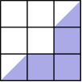
在这个区域中，有三个深色单位正方形，另有两个深色三角形合起来形成一个单位正方形。
因此深色区域面积为 4，整个区域面积为 9。所求分数为 4/9。
所以正确答案是B。
English
Notice that there are repeating 3 × 3 regions with the same pattern (they might be rotated differently).
In this region, there are three dark unit squares and two dark triangles that combine to form another unit square.
This makes the area of the darker region 4 and the whole region 9. The desired fraction is then 4/9.
Thus,Bis the correct answer.
第 24 题 答案 B
使用 6 个梨和 6 个橙子，这样两种水果数量相同。
因为 3 个梨榨出 8 盎司，6 个梨榨出 16 盎司。因为 2 个橙子榨出 8 盎司，6 个橙子榨出 24 盎司。
混合果汁总量为 16+24=40 盎司，其中 16 盎司是梨汁。梨汁百分比为 16/40=40%。
所以正确答案是B。
English
Use 6 pears and 6 oranges, which is an equal number of each fruit.
Since 3 pears make 8 ounces, 6 pears make 16 ounces. Since 2 oranges make 8 ounces, 6 oranges make 24 ounces.
The blend has 16+24=40 ounces total, of which 16 ounces is pear juice. The pear-juice percent is 16/40=40%.
Thus,Bis the correct answer.
第 25 题 答案 B
因为只有各人所给钱数占原有钱数的比例重要，所以假设每个人都给 Ott $1。这意味着 Moe 原来有 $5，Loki 原来有 $4，Nick 原来有 $3。
转账不会改变这群人的总钱数，即
$5 + $4 + $3 = $12。
Ott 现在有 $3。
因此 Ott 拥有这群人总钱数的
3/12 = 1/4，
也就是四分之一。
所以正确答案是B。
English
Because only the fractions matter, suppose each person gave Ott $1. This means that Moe had $5, Loki had $4, and Nick had $3 originally.
The transfers do not change the group’s total amount of money, which is
$5 + $4 + $3 = $12.
Ott now has $3.
This means that Ott has
3/12 = 1/4
of the group’s money.
Thus,Bis the correct answer.

